Andre Miranda
CS-405 Secure Coding
Professor Olga Mill
July 22nd, 2026

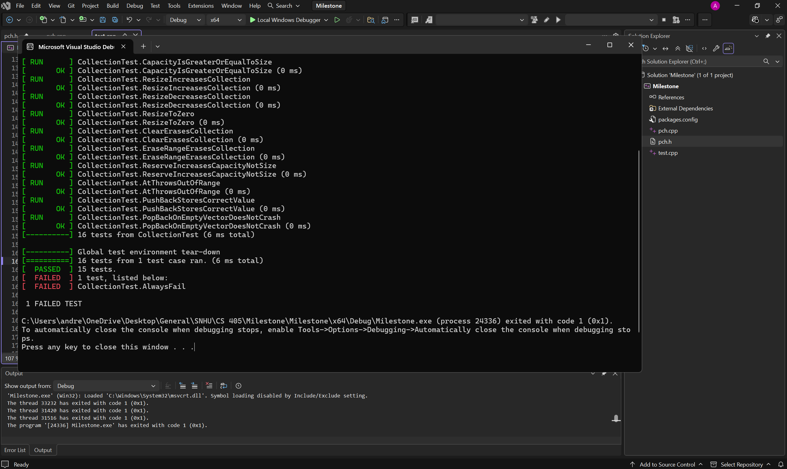

Summary
For this milestone, I created a new Google Test project in Visual Studio to ensure a clean and stable environment for unit testing. My initial attempts used an older project configuration that produced linker errors related to mismatched GoogleTest library paths. To resolve this, I started fresh with a new Google Test project using the recommended settings: consuming GoogleTest as a static library and linking the C++ runtime dynamically. This ensured that Visual Studio generated the correct pch.h and pch.cpp files and restored all required NuGet dependencies.
Once the project was created, I replaced the default sample test with the full suite of tests required for the assignment. This included the global test environment, the CollectionTest fixture, the three starter tests provided in the instructions, eleven required tests covering vector behavior, and two custom tests which included one positive and one negative. I verified that all test code was placed in test.cpp and that pch.cpp contained only the precompiled header include, which is necessary for proper compilation.
After setting up the test suite, I built the project to confirm that all dependencies were correctly linked and that the test code compiled without errors. I then ran the tests using Visual Studio’s Test Explorer and the Local Windows Debugger. The output showed that all tests executed successfully, with fifteen passing and one failing. The failing test was the intentional AlwaysFail test included to demonstrate that the test framework correctly reports failures.

